RAPTOR Worklist Item Ranking Algorithm

Last Updated 20140612

# Overview

The worklist shows all logged in users the uncompleted orders, but the sort varies by logged in user and day they are logged in. The RAPTOR Ranking Algorithm is used by the program to sort the entries displayed in the worklist page to the user.

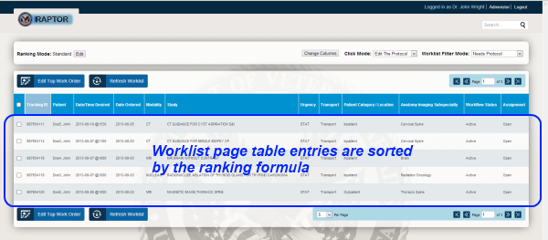

*Figure 1 - Location of sorted content*

This algorithm assigns a ranking score to each row and then displays the rows with higher scores before rows that have lower scores. This is the only sort on the worklist rows unless the user overrides this behavior by manually sorting the rows of the worklist.

The ranking scores are computed each time the worklist is.

# Ranking Algorithm Details

Each row of the worklist is assigned a ranking score value by apply the following criteria to each row.

1. Initialize the ranking score as value **0**
2. If urgency of the procedure is ”STAT” then add **500** to score
3. If urgency of the procedure is ”URGENT” then add **250** to score
4. If the procedure is already assigned to the logged in user add **100** to the score
5. If the procedure has a specialization keyword match to the logged in user then add either **20**, **10**, or **5** points to the score for each match depending on the keyword group the match occurs in.
6. If procedure modality matches to modality associated with the logged in user add **20** points to the score.
7. Add **1** point to the score for every week that has passed since the procedure order date.
8. Add **10** points to the score for every day that has passed since the requested due date.
9. Add 900 points to the score if scheduled date has passed.
10. Add 500 points to the score if scheduled date is within 24 hours.
11. Add points computed by formula (100/days) if scheduled for within 7 days.

# Scoring Examples

For purposes of illustration, consider the following five uncompleted procedures A, B, C, D, and E.

## Procedure order A

1. Urgency=URGENT
2. Assigned To=**Dr. J Wright**
3. Anatomy=Knee
4. Modality=CT
5. Order Placed Date=10/5/2013
6. Order Requested Due Date=10/10/2013

## Procedure order B

1. Urgency=URGENT
2. Assigned To=*blank*
3. Anatomy=Neck
4. Modality=CT
5. Order Placed Date=10/1/2013
6. Order Requested Due Date=10/10/2013

## Procedure order C

1. Urgency=URGENT
2. Assigned To=*blank*
3. Anatomy=Neck
4. Modality=CT
5. Order Placed Date=10/5/2013
6. Order Requested Due Date=10/8/2013

## Procedure order D

1. Urgency=STAT
2. Assigned To=*blank*
3. Anatomy=Neck
4. Modality=CT
5. Order Placed Date=10/10/2013
6. Order Requested Due Date=10/10/2013

## Procedure order E

1. Urgency=*blank*
2. Assigned To=*blank*
3. Anatomy=Ankle
4. Modality=CT
5. Order Placed Date=10/1/2013
6. Order Requested Due Date=10/10/2013

## User 1 Example Default Sorting

If Dr. J Wright is a ***CT*** and ***Knee*** specialist and is logged in on 10/8/2013, the procedures will have the following ranking scores.

1. A=250+100+20+20+0+0 → 390
2. B=250+0+0+20+1+0 → 271
3. C=250+0+0+20+0+0 → 270
4. D=500+0+0+20+0+0 → 520
5. E=0+0+20+1+0 → 21

Thus, the procedures will by default appear in Dr. J Wright’s worklist in the following order: D,A,B,C,E

## User 2 Example Default Sorting

If Dr. J Macedon t is a ***CT*** and ***Neck*** specialist and is logged in on 10/8/2013, the procedures will have the following ranking scores.

1. A=250+0+0+20+0+0 → 270
2. B=250+0+20+20+1+0 → 291
3. C=250+0+20+20+0+0 → 290
4. D=500+0+20+20+0+0 → 540
5. E=0+0+20+1+0 → 21

Thus, the procedures will by default appear in Dr. J Macedon’s worklist in the following order: D,B,C,A,E